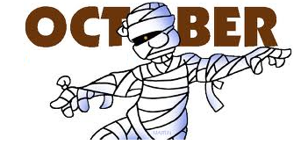

**What’s happening in Grade 5?**

*In French we have started our first unit on Ma famille (My Family). We are discussing family members’ ages, eye and hair colours and what they like (ex: sports, fishing etc…). French reading practice at home will start soon. Only if you wish, have your child read to you (don’t worry if you don’t understand French, it’s the practice that counts!) I have recorded my voice reading each book. Please check out my teacher page on the school website.

*In Math students are finishing their pattern and equation unit. The next unit is whole numbers. They will be reading, writing and describing numbers to one million, adding and subtracting 4 digit numbers and estimating numbers to one million



**Important Reminders**

**\*Cross Country @ Stanley 10:15**

**\*No School for students October 6th, 7th and 10th**

**\*Safe Schools Week—Oct 11th- 14th**

**\*Halloween Multi-Age Activities— October 31st @ 12:15**



**Book Orders**

Book Orders will be sent home **Wednesday, October 5th**and expected to return on **Wednesday, October 12th**

Thank you! ☺

If you have any questions or concerns, please contact me by email: Maureen.O’Donnell@nbed.nb.ca

or

call the school 369-2000

School Website is up and running!

Bonne Fête

Aucun Fête

No Birthdays





Website of the Month: Number Line Game http://numbaland.com/

(Math games)